Nowcasting US GDP Growth
Nowcasting US GDP Growth
DSE3101 Project Technical Documentation

DSE6789
Ang Kok Chun (A0273169W), Aninda Metta Citta (A0282479M), Jennifer Liu Zixuan (A0283094Y), Jillian Ashleigh Loh Li Ann (A0282748N), Low Yen Charlotte (A0281761B), Vismay P Menon (A0273146E), Quek Chui Qing (A0283134J), Wang Yifei (A0281785N)

8 April 2026

Link to app: https://vismaypmenon.shinyapps.io/tkachenko_capital/
Link to GitHub Repository: https://github.com/vismaymenon/DSE6786-Nowcasting.git

PART I

1.1 Project Overview
In an investment banking environment, timely and accurate assessments of macroeconomic conditions are critical for informed decision-making. Among the key indicators of economic performance, U.S. gross domestic product (GDP) plays a central role in shaping capital markets activity, credit conditions, asset pricing, and overall risk sentiment (Kramer, 2024). However, official GDP figures are released quarterly with a significant lag and are subject to subsequent revisions, creating a persistent information gap between real-time market developments and confirmed economic data (Lubik & Titcomb, 2026). For an investment bank operating in fast-moving financial markets, relying solely on published GDP figures is insufficient for strategic planning and execution.
The primary business question guiding this project is: how can the bank obtain a reliable, continuously updated estimate of U.S. GDP growth to support capital markets, trading, and risk management decisions? To address this, we developed a GDP nowcasting dashboard, an application that produces real-time estimates of current-quarter GDP growth by synthesising a broad set of higher-frequency economic indicators as they become available throughout the quarter.
The project is built using the following core tools: Python for all data ingestion, transformation, and modelling; FRED (Federal Reserve Economic Data) as the primary data source; Supabase as the central database layer; Shiny for Python with Plotly for the interactive frontend.

1.2 Overall Design

1.2.1 Architecture: The application follows a four-stage pipeline. In the first stage, load_data.py pulls GDP data from FRED and performs initial transformations, producing a monthly data (md) and a quarterly dataset (qd). In the second stage, ragged_edge.py handles the unbalanced nature of real-time data by imputing missing values and storing them in two new datasets, filled_md and filled_qd, so that models can be estimated on a complete regressor matrix. In the third stage, fred_loader.py pushes all datasets into Supabase, which serves as the central database. In the fourth stage, each model queries Supabase for its required inputs, produces nowcast estimates, and writes results back to a models_forecasts table. The Shiny frontend then queries models_forecast to populate the dashboard.

1.2.2 Front End Data flow: The model_forecasts table is the single interface between backend pipeline and frontend. On the frontend, four data access functions are defined as clean stubs with documented table schemas: fetch_nowcast_data retrieves model predictions for a selected quarter, fetch_confidence_intervals retrieves the corresponding uncertainty bounds for a chosen model, fetch_historical_data retrieves actuals and model predictions over a user-specified date range conditioned on the flash estimate month, and fetch_rmse retrieves RMSE for selected models. Each function queries Supabase directly, returning live model outputs to the frontend. No model estimation occurs at runtime; all nowcast values are pre-computated and stored, keeping the frontend lightweight and responsive.

1.3 Data and Methodology
In this section, we will briefly describe the data and methodology used for this nowcasting project. More details will be available in Part II.

1.3.1 Datasets
The primary data source is the Federal Reserve Economic Data (FRED) Quarterly Database (QD) and Monthly Database (MD) maintained by the Federal Reserve Bank of St. Louis. The target variable is U.S. real GDP growth (GDPC1_t), expressed as an annualised percentage change of GDP growth calculated from the quarter-on-quarter log difference as recommended by FRED. For the benchmark models, the predictor set is constructed from the remaining variables in QD. The other models were constructed with both datasets. Across all five tables, sasdate serves as the primary key and the common join key across the pipeline. The latest datasets were downloaded from the web via a .csv (comma separated values) hyperlink.

1.3.2 Pre-processing and feature engineering
Not all the data in QD and MD are filled completely, because the series are released at different times. This is referred to as the “ragged edge” problem. The ragged edge is filled by an autoregressive model AR(p). Outlier COVID-period effects are captured through two dummy variables – covid_crash and covid_recover to mark data from 2020 Q2 and 2020 Q3 respectively.

1.3.3 Modelling and Analytical Techniques
The benchmark model is an autoregressive AR(2) model.

Next, LASSO regression and Random Forest (RF) models are trained on mixed-frequency data, which is dealt with in 2 ways. The first strategy is taking the simple average of the 3 months in each quarter. The second strategy is the Unrestricted Mixed Data Sampling (UMIDAS) Approach, which takes each month in the quarter as a predictor, as well as the quarterly data.

Lastly, we will take a simple average of all the LASSO and RF models to create an ensemble model. Table 1 shows the different nowcasting models built.

1 | 3 | 4 | 5 | 6 | 7 | 8
AR benchmark | LASSO + Simple Average | LASSO + Simple Average + Lags | LASSO + UMIDAS | RF + Simple Average + Lags | RF + UMIDAS + Lags | Ensemble
Table 1: List of All Nowcasting Models

The models are evaluated based on a pseudo-out-of-sample forecast, using root mean squared error and mean absolute error as metrics. Additionally, Diebold Marino (1995) tests are conducted for every pair of models to determine whether they have significantly better predictive ability than the other models.

PART II

2.1 Data Sources, Cleaning and Transformation

2.1.1 Loading Data

In load_data.py, the latest FRED MD and QD data is extracted from the .csv links provided by FRED. Each series is then transformed based on the recommended transformation by McCracken and Ng (2016) for MD and McCracken and Ng (2020) for QD. The target variable is extracted from the log-differenced (the recommended transformation) GDPC1 series in QD and annualised by multiplying it by 400. We also drop columns that were dropped by both papers to create a balanced panel and remove irregular series without losing observations. We also removed series that are either highly correlated with GDP, like Real Value-Added Output (see Fig. 1), which are calculated from GDP figures. Finally, we also dropped the series in QD that also appears in MD to avoid redundant information from the same variable being represented at two different frequencies, which would introduce multicollinearity and dilute the mixed-frequency signal that our models later rely on. Table A in the Appendix shows the full list of reasons behind why each series was dropped. Real GDP components that remain in the dataset — PCECC96 (consumption), GPDIC1 (investment), and EXPGSC1 (exports) — are restricted to entering only as lags, never contemporaneously, for the same reason: using them same-quarter would let a model partially reconstruct GDP from its own components rather than genuinely forecast it.

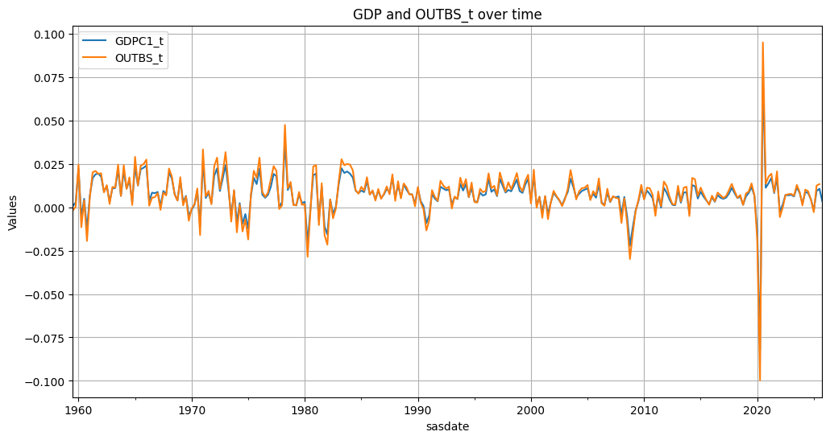
Figure 1: Plot of target variable with transformed Business Sector: Real Value-Added Output (OUTBS)

2.2 Modelling and Analysis

2.2.1 Benchmark Models

Our benchmark model is an AR(2) model. 2 lags were determined based on testing out a range of possible p lags up to p = 12, and using the Aikaike Information Criterion (AIC) to determine that the optimal number of lags is two. The AR(2) model is implemented via Ordinary Least Squares (OLS) on two lagged predictors using the statsmodels package. The equation of the model is shown below. When the immediately preceding quarter's GDP is not yet released, the benchmark uses a direct 2-step forecast instead — regressing GDP growth on the t-2 and t-3 lags directly, rather than imputing the missing t-1 lag from another model's prediction. This keeps the benchmark a genuine floor: it only ever uses real, released GDP history.

${GDP}_{t}=β_{0}+{β_{1}GDP}_{t-1}+β_{2}{GDP}_{t-2}+ ε_{t}$

2.2.2 Nowcasting Models

To predict GDP growth in each quarter, all models broadly follow these steps:
- Ragged edge filling: the ragged edge problem occurs where different series are released up to different periods. All models use AR(p) to fill in the ragged edge.
- Frequency adjustment: we used a bridge model (simple average) or Unrestricted Mixed Data Sampling (U-MIDAS) to transform monthly data into a quarterly series. This allows us to take in account both monthly and quarterly data as predictors of quarterly GDP growth.
- Final model: for the final model, we used LASSO or Random Forest (RF). For some models, we included lags of the predictors and GDP growth.

By taking a combination of the frequency adjustment method, final model, and lag selection, we constructed the 5 models as seen in Table 1. Finally, we take a simple average of the predictions made by these models to produce an Ensemble Model prediction.

2.2.2.1 Ragged Edge

In ragged_edge.py, missing values caused by unreleased data are predicted using AR(p) models with the number of lags p decided based on the Bayesian Information Criterion (BIC) for each series. The number of lags tested for MD was p=1, 2… 12, and for QD was p = 1,2,3,4. Both AIC and BIC were tested for selecting p. BIC applies a heavier penalty than AIC, so it tends to select fewer lags. More importantly, BIC prioritises stable model fit, while AIC prioritises predictive accuracy of the target variable. Since our goal here is to accurately reconstruct the missing values, BIC is the better criterion. Any error in the ragged edge carries forward into our models, so we want the most stable fill possible. The list of p lags for each predictor in MD and QD is combined in bic_lags.csv, which was generated by ragged_edge_working.py. The data is filled up to the last month of the current quarter, to enable models to nowcast GDP up to the current quarter with all the months in that quarter.

2.2.2.2 Transforming Higher Frequency Data

We use two methods to transform higher frequency data – the Bridge Model and the Unrestricted Mixed Data Sampling (UMIDAS) approach.

The Bridge Model takes a simple average of the three months in a quarter for each variable as predictors.
$x_{Q}=\frac{1}{3}(x_{Q,1}+x_{Q,2}+x_{Q,3})$
Where $x_{Q,m}$ refers to the monthly value of variable $x$ in the $m$th month of quarter $Q$ (e.g. $x_{Q1 2025,1}$ refers to $x$ in Jan 2025). Following this, each $x_{Q}$ is used as a predictor for our target variable, quarterly GDP growth.
$y_{Q}=$${ β}_{0}+\sum_{j=1}^{P}{}β_{j}x_{Qj}+ ε_{Q}$

The U-MIDAS approach allows for more flexibility. Instead of a simple average, it takes a weighted average of each month, to allow the model to determine which month’s data is more informative. This effectively creates separate variables for each month.

$y_{Q}=...+w_{1}x_{Q,1}+w_{2} x_{Q,2}+w_{3} x_{Q,3}+...$

With these two methods, four different design matrices were created. For each method, we created two different design matrices, one including lags of each variable (four lags) to create an ADL-like design matrix. The four different feature matrices are listed below in Table 2.

Design Matrix | Frequency Adjusting Method | Inclusion of Lags for X variables | Inclusion of GDP Lag
X1 | Bridge (Simple Average) | No | Yes
X2 |  | Yes
X3 | U-MIDAS | No
X4 |  | Yes
Table 2: Characteristics of Design Matrices

Each design matrix is created by a function in output_x.py. The function first calls the filled ragged edge data from Supabase with load_filled_data() and _load_gdp(). With _add_lags(), lagged QD and MD variables are created for X2, X4, and lagged GDP for all matrices. Particularly, 4 quarters of lag or 12 months of lag were created, as a year represents the maximum plausible horizon where volatile economic variables can contribute significantly to predicting other variables.

2.2.2.3 Final Model

The Final Model was either LASSO or Random Forest. These two models were chosen because LASSO and Random Forest are models that perform some kind of feature selection, which performs better on high dimensional models like ours, with a similar number of both number of observations and number of predictors. Both LASSO and Random Forest was run on the four different feature matrices, with some exceptions: LASSO was not run on X4 because our current hdmpy-based implementation does not complete in reasonable time on X4's column count; LASSO itself is used in the literature with far larger predictor sets; Random Forests was not run on X1 or X3, because Random Forest performs better with more variables, and the design matrices with lags added were used.

Least Absolute Shrinkage and Selection Operator (LASSO) Regression

To select relevant variables, we used the LASSO regression function rlasso() from the hdmpy package (Chernozhukov et. al. 2016). LASSO regression is useful in high dimensional cases where the number of variables is large relative to the number of observations. LASSO does this by simultaneously shrinking variable coefficients to zero to perform feature selection, and regression. This is done by adding a penalty term to the loss function of the traditional Ordinary Least Squares estimator (see Equation 2). We implemented Post-LASSO to get the function to re-estimate the coefficients after removing the variables that have had their coefficients shrunk to zero for better performance. Due to serial autocorrelation, we used homoskedasticity = False to get heteroskedastic consistent estimates.
$\hat{β}=argmin\frac{1}{N}\sum_{i=1}^{N}{}(y_{i}-X_{i}β)^{2}+\frac{λ}{N}\hat{ψ}\left|β\right|$
Where $\hat{β}$ is the vector of estimated coefficients, N is the number of observations, $y_{i}$ is the GDP target variable, $X_{i}$ is the feature matrix for the ith target variable, $λ$ is the penalty factor and $\hat{ψ}$ is a diagonal matrix of penalty loadings. For our case, $\hat{ψ}$ and $λ$ are calculated using a data-driven approach instead of cross validation. In particular, the penalty factor is calculated by the following equation:
$λ=2c\sqrt{n}Φ^{-1}(1-\frac{γ}{2p})$
where theoretical constant c = 1.1, p is the number of predictors, and probability level $γ$ is kept at its default value 0.1.

Random Forest
Random Forest is an ensemble model that constructs multiple decision trees. Each tree is trained on a bootstrapped sample of the training set, and every split is determined by a random subset of features. The final prediction is calculated as the average of the outputs from all individual trees. The random forest is implemented using the RandomForestRegressor function in scikit-learn. For each training set, 1000 trees were built, using 30% of the original features (max_features = 0.3).

2.3 Evaluation

In order to compare our 6 models, we use three different measures. First, we compare both the root mean square forecast error and the mean absolute forecast error using a pseudo-out-of-sample forecast method. Second, we use the Diebold-Mariano (1995) test (DM test) for the null hypothesis of equal predictive accuracy to determine if the predictive superiority of our models is significant. Note: the RMSE and DM figures in this section (Table 5 and Appendix Tables B–D) predate the AR-benchmark, GDP-lag, and DM-loss-function fixes described above (Sections 2.2.1, 2.1.1, 2.3.3) — they are pending a re-run of the full historical POOS pipeline and will be refreshed in a follow-up update, not fabricated or hand-edited here.

2.3.1 Pseudo-Out-of-Sample (POOS) Forecasts
Our final product produces 6 versions of the nowcast for each quarter, made in 6 different months. The first prediction is made on the last day of the first month of the quarter, while the last prediction is made on the last day of the last month of the following quarter. These predictions will henceforth be referred to as versions 1 to 6. We do POOS separately for each of these 6 versions, as the prediction made in the first month can differ significantly compared with that made in the sixth. Based on our observation, data availability for most features is as follows:

Version | Fred_md available | Fred_qd available | GDP actual available
1 (1st month of the Q, M) | M-3 | Q-2 | Q-2
2 (2nd month of the Q, M+1) | M-2 | Q-2 | Q-2
3 (3rd month of the Q, M+2) | M-1 | Q-1 | Q-1
4 (1st month of Q+1, M+3) | M | Q-1 | Q-1
5 (2nd month of Q+1, M+4) | M+1 | Q-1 | Q-1
6 (3rd month of Q+1, M+5) | M+2 | Q | Q-1
Table 3: Data Availability for Each Nowcast Version

The POOS forecasts were made using a rolling window approach in order to calculate RMSEs and conduct DM test comparisons (see Section 2.3.3). For each POOS step, which makes use of 1 of the 100 data points in the test set, 162 data points before it make up the train set. We first simulate the data availability at the point. Depending on the version of the model, data available for MD, QD and GDP are different (Table 3). We cut the datasets to the corresponding levels and then apply the ragged edge filling up to the quarter predicted. This allows the error introduced by the ragged edge to affect this POOS estimate. Hence, we avoid data leakage and our model evaluation effectively reflects the accuracy of future predictions. In calendar terms, the 100-quarter test period runs from 2001Q1 to 2025Q4, with training data drawn from as early as 1960Q3.

With the filled table, we build the design matrix and train the model evaluated. The trained model is then used to predict the GDP of the test datapoint, and the prediction can be compared to the actual GDP. The entire process is repeated for each of the 100 test data points. This is implemented in run() in historical.py, where poos_validation() is called 6 different times.

2.3.2 Root Mean Squared Forecast Error (RMSE) and Confidence Intervals
The RMSE was calculated based on taking the difference between the predicted and nowcasted values of GDP in the test set. These values are then upserted into the rmse table in Supabase using calculated_and_upsert_rmse() in evaluation_table_history.py. Because each model nowcasts GDP for each quarter 6 times (see Section 2.3.1), there are 6 separate RMSE values for each model to reflect the different accuracies of each model with access to different amounts of information. The 3 quarters of Covid-19 volatility (Q2, Q3 and Q4 2020) were removed to prevent outliers from influencing RMSE values too much.

Confidence intervals for each nowcast are calculated based on the RMSE of predictions in the test set. The training data used to predict each test set point takes the latest released values for the indicators in the previous quarters, which results in seemingly very accurate predictions. These residuals, however, are not representative of our monthly predictions. Our monthly predictions are limited to using ragged-edge filled values and flash estimates of features. As such, calculating confidence intervals from the training data is unable to produce realistic intervals for each test set point, because the residuals in the training set are too small. Hence, update_ci_columns() in ci_update.py takes the RMSE values from the rmse Supabase table directly to multiply it with the 50% and 80% Gaussian critical values (0.674 and 1.282) to obtain a confidence interval for each model version, assuming forecast errors are approximately Normally distributed. Because RMSE excludes the 2020 COVID-19 quarters as outliers (Section 2.3.2), these intervals also exclude that tail-event variance, which likely makes them tighter than the true unconditional uncertainty in GDP growth.

2.3.3 Diebold-Mariano (DM) Test
The Diebold-Mariano (DM) test is a statistical test used to determine whether the difference in predictive accuracy between two competing forecasting models is statistically significant. In dm_test.py, the latest forecast data from the model_forecast table in Supabase is fetched to provide the nowcasts from each model. The function dm_test() outputs the DM test statistic based on these nowcasts. In dm_test(), the difference in the loss for each unique model pair is first calculated. Squared error is used in this case, consistent with the RMSE figures reported alongside each DM test. A regression on a constant using the OLS function in statsmodels was used to obtain the heteroskedastic and autocorrelation consistent standard errors for the difference based on Newey & West (1994). Additionally, because the sample size is relatively small (n=97), the correction proposed by Harvey et. al. (1998) for finite sample sizes was used to obtain a more accurate DM test statistic. P values were calculated using a two-tailed test on a T distribution with n-1 degrees of freedom.

All model POOS predictions were made using the rolling window approach to enable DM test comparisons, since many of the models are nested within each other.

2.3.4 Results

2.3.4.1 Version Performance
Comparing the mean RMSE of each version, we see that unsurprisingly, the best nowcasts are made later in the prediction window, as more data is available (visible in Table 5, whose per-version RMSE declines as more data becomes available; the full model × version RMSE grid is in Appendix Table C). Version 6 nowcasts tended to be exceptionally accurate, which reflects the possibility that the GDP flash estimates would already be out at this time, along with other macroeconomic indicators that are calculated in the same fashion. Because our POOS does not take into account data vintages, this means that our version 6 nowcasts might be taking in the latest “true” indicators and hence there may be data leakage occurring.

2.3.4.2 Model Performance (RMSE)

It is difficult to make meaningful comparisons of models across the different versions, because models that tend to perform well for earlier nowcasts may not be the same models that perform well as more information becomes available. Nevertheless, we have attempted to do so to make it easier to display relative model performance on the front end by taking the mean of the nowcasts across all versions (See Appendix Table C). This is saved as version 0 on the rmse table in Supabase. Based on this analysis, the LASSO models perform the best, followed by the averaged model, followed by the random forest model. Our benchmark AR(2) model performs the worst when analysed this way, which is reasonable given that it does not take in any monthly indicators and will not have its performance vary over the different months. However, this might be affected by the fact that LASSO models tend to perform better in versions 5 and 6 (see Table 5) as they are better able to take advantage of the data leakage as mentioned in Section 2.3.4.1.

A better way to analyse these results is to analyse the RMSE of each model-version pair. The best performing model for each version is shown in Table 6. These three models were selected for eventual display on the front end due to their higher forecast accuracy. As discussed, the RF models tend to fare better earlier on, while the LASSO models do better as more data comes in.

Best performing model for each version | Version | RMSE | Benchmark RMSE
RF_Lags_UMIDAS | 1 | 2.375 | 2.605
RF_Lags_UMIDAS | 2 | 2.366 | 2.605
RF_Lags_Average | 3 | 2.273 | 2.482
RF_Lags_Average | 4 | 2.225 | 2.482
RF_Lags_Average | 5 | 2.211 | 2.482
LASSO_UMIDAS | 6 | 0.410 | 2.482
Table 5: Best performing model for each prediction version

2.3.4.3 Model Performance (DM Test)

To identify if the difference in predictive accuracy of these models are significant, we conducted pairwise DM tests as specified in Section 2.3.3.

At the 5% significance level, all null hypotheses that the models predict similarly cannot be rejected except for the LASSO models compared to the rest of the models, and the RF models compared to the AR(2) benchmark for version 6 predictions. Because version 6 is prone to data leakage, we will not discuss this further.

Table D in the Appendix shows the DM tests that are significant at the 10% significance level. In general, the RF models and the All Model Average predicted significantly more accurately than the AR benchmark and the LASSO models.

2.3.4.4 Key Indicators Identified

LASSO and Random Forest are both machine learning models which can perform variable selection, and hence give some insight into which factors can predict GDP the best. However, because the models are retrained every time a new prediction is made, the significant indicators change with each forecast. However, we can identify some general trends to indicators that are consistently selected by both models for more recent forecasts. Some of these indicators are listed in Table 6, while the feature importance plots and LASSO coefficients can be found in the Appendix.

Series ID | Frequency | Transformation | Name of Indicator
PCECC96 | Quarterly | Log difference | Real Personal Consumption Expenditures
GCEC1 | Quarterly | Log difference | Real Government Consumption Expenditures and Gross Investment
EXPGSC1 | Quarterly | Log difference | Real Exports of Goods and Services
UNRATEST | Quarterly | Difference | Unemployment Rate less than 27 weeks (Percent)
IPB51110SQ | Quarterly | Log difference | Industrial Production: Durable Consumer Goods: Automotive Products
ULCBS | Quarterly | Log difference | Business Sector: Unit Labor Costs for All Workers
GPDIC1 | Quarterly | Log difference | Real Gross Private Domestic Investment
SRVPRD | Monthly | Log difference | All Employees, Service-Providing
Table 6: Some indicators that were selected by LASSO and RF.

Unsurprisingly, indicators that sum up to GDP were highly selected for, such as indicators related to consumption (PCECC96), investment (GPDIC1) and exports (EXPGSC1). Additionally, many variables measuring the percentage growth of the number of employees (SRVPRD) were also selected for, which might be a proxy for the strength of the labour market that is correlated with GDP.

2.3.4.5 Limitations and Future Work

A key limitation of this project is the limited availability of the vintage data. Vintage data is a historical record of what the data actually looked like at each point in time. Our current method of simulating data availability, mentioned in section 2.3.1 is still using final revised values, not the actual numbers that were available at that moment, which may have been inaccurate. This might also be the reason for the data leakage phenomenon that is responsible for the unrealistic performance of the version 6 predictions. We chose not to run our analysis on the vintage data because it only goes back to 2018 for FRED QD, which is too small to be used to reliably evaluate model performance. This means that the RMSE generated from the models are likely to be overly optimistic especially for the later versions (e.g.: version 6). That said, this only affects our historical backtesting. Once the app is live, each nowcast is generated using only the data available at that point in time, so data leakage is not a concern in future nowcasts.

2.5 Data Storage

All forecasts and metrics are uploaded onto Supabase, an open-source Backend-as-a-Service (BaaS) platform run on a PostgreSQL database. This is to reduce loading time for the front end, which can directly load data from Supabase to bypass the model run time and reduce processing time. The list of Supabase tables and how they are maintained can be found in Table E. Subabase tables are maintained by an upsert (update and insert) process where only new values are inserted to reduce runtime.

2.6 Roles and Responsibilities

Each team member contributed to all aspects of the project. Discussions on the direction and implementation logic of key functions (e.g.: POOS) were conducted with all group members. Coding work was distributed amongst members such that each member was individually responsible for a few files and functions. As an example, Aninda wrote historical.py, Yifei wrote output_x.py, Jennifer wrote poos.py and Chui Qing wrote dm_test.py, although we often crossed over and edited each others’ code to fix errors. Nearer to submission, the work for the individual requirements were split such that Aninda and Jennifer were more focused on finalising the code while Chui Qing and Yifei worked on the technical documentation, video and slides to improve efficiency.

2.7 Reflections

The timeline was tighter than expected, with much of the work completed close to the submission deadline. This was not ideal, particularly because the front-end team had to delay loading the actual predictions until very late in the project, which caused some stress. This was despite the team having started work as soon as the project proposal feedback was returned. Part of the reason it took so long is that many problems and ideas only surfaced late in the project. Another hurdle was that the models took quite long to run, especially the Lasso regression and some of the U-MIDAS lagged datasets, which had a large number of variables. To enable the historical data function on the front end, the table values needed to be populated by running the models over a large time period, taking several hours even with multiple devices running in parallel. Although this only needed to be done once (after which the front end can pull the data almost instantly from Supabase), any error or loophole detected in the code required the entire process to be restarted from scratch.

There was a huge deviation from the initial proposal, which was too ambitious. The team underestimated how complicated nowcasting even with simple bridge equations will be. The true challenge was not in creating a better model but in developing an organised and reliable pipeline for running the code and evaluating the models accurately. Additionally, a key issue we faced was overperformance of some models due to data leakage. It took a long time to think of and implement the cut and fill method of POOS, which also meant that we had to overhaul large parts of the code to adjust for the new method. It was quite fortunate that all four members stayed in the same compound on campus and could readily meet to fix these problems.

PART III

3.1 Structure and Layout

The dashboard consists of a main graphical display that occupies most of the screen, and a ‘control panel’ on the right, consisting of different selections the user can make that correspond to the data they would like to retrieve and visualise. The application consists of 2 tabs which both follow this layout: (1) the Nowcast tab that allows users to visualise our Nowcasted GDP growth values for the current and two preceding quarters, and (2) the Historical Values tab that allows users to see how our Nowcasting models would have performed based on past data, compare these predictions to the actual released values & view evaluation metrics for each model.

When the user first opens the app, they can choose to enter or skip an onboarding wizard, which brings them through the different components and functionalities of the app, and adds more context which can be helpful in their understanding. They can replay this tutorial at any time.
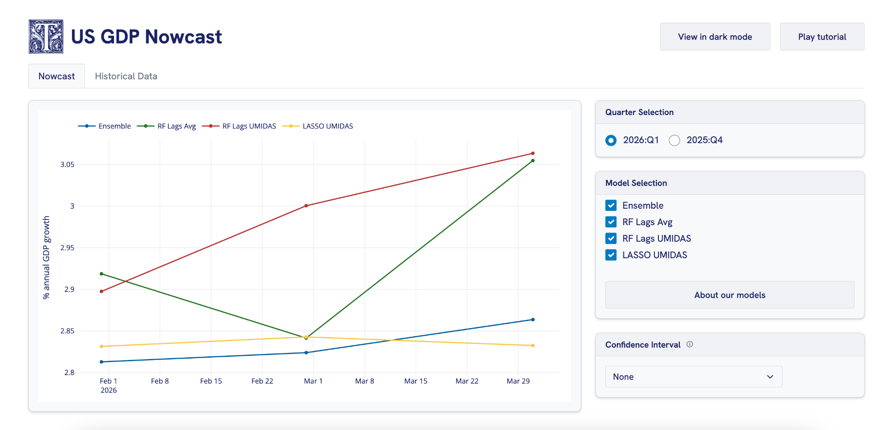
Under the Nowcast tab, users are able to view the Nowcasted values by different models for the 3 most recent quarters. They can make changes to the quarters & models selected, and choose whether or not they want to display the confidence intervals of one of the models (which are overlaid on the graph as shaded regions). They can also view descriptions of each model.

Under the Historical Data tab, users are able to view the predicted values for past periods. They are able to select the time frame, model, and flash estimates, which refers to the month in a particular quarter the prediction would have been made. Evaluation metrics, such as the RMSE & DM test t-statistics were also provided to help users evaluate how the models perform relative to one another.

3.2 User Analysis
The assumed users of this app are analysts working in an investment bank, using it as an internal tool to make decisions based on the most current estimates of GDP growth data available. Since this group of users can span interns to senior analysts, they may have quite a varied range of expertise levels, hence it was important for us to provide sufficient user orientation. This can include definitions of technical terms, and explanations of what certain statistics represent.

Since our assumed users would likely access our app to get a better understanding of current economic conditions to inform their decision-making processes, it was also crucial that they were able to easily retrieve relevant data.

In order to choose the best model for the data they require, users would also need to be able to evaluate and compare the models

3.3 Design Decisions
To guide our design decisions, we referred to the design heuristics laid out by Preece et al. in Interaction Design: Beyond Human-Computer Interaction. For this section, we will refer to selected principles and demonstrate how our product applies them in order to ensure usability and optimise user experience.

3.3.1 Error Prevention
According to Preece et al., user error should be prevented by eliminating error-prone conditions. As such, we took care to include restrictions that prevent users from selecting options that result in the content being displayed being too cluttered, which negatively impacts usability. For the selection of Confidence Intervals (CI) to be displayed, we used a dropdown menu rather than checkboxes because it enforces a single-model constraint – a user can only view the confidence band for one model at a time, preventing the chart from becoming cluttered with overlapping shaded regions.
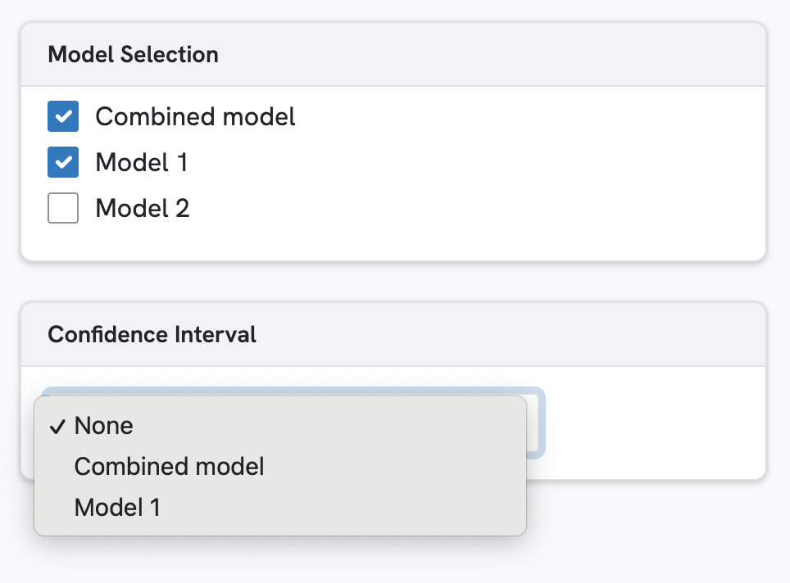
Crucially, we also made sure that users could not make selections that resulted in their desired data being unable to be displayed at all. This reduces the likelihood of users arriving at frustrating states where they face errors. For example, the dropdown selection for Confidence Intervals is dynamically constrained through a reactive.effect so it only ever offers models that are currently checked and resets to “None” on any model selection change, ensuring the CI band is never shown for a model not already visible on the chart.

3.3.2 User Control & Freedom
Our app follows the layout of a dashboard, which is a format that is commonly used in investment banking, for example the Bloomberg Terminal, where the user is able to make selections in order to view real-time financial data. Given these digital products that our assumed user is already accustomed to, we wanted to ensure that the user is able to experience a similar sense of agency and control as they navigate our interface to obtain the data they need. In order to communicate this to them, we ensured that they were able to exit any given state without having to go through a lengthy series of dialogs. For instance, we included ‘x’ buttons for users to exit the onboarding wizard at any step, and we included a ‘Play tutorial’ button at the top of the page so that the user can revisit it whenever they need to.

3.3.3 Recognition Rather than Recall
We took care to minimise the user’s memory load by making objects, actions, and options visible and easily retrievable. Within the onboarding wizard we ensure that the user understands the different functionalities of the app as well as certain pieces of information that may be more technical (e.g. what the ‘flash estimate’ under the Historical Data tab’s display options refers to). Beyond this initial user orientation, we have several tooltips integrated into the interface so that the user can retrieve this information whenever they need it. This ensures that the user does not have to remember information from one part of the interface after they have navigated to another section. Additionally, in the DM statistics table overlay, the RMSE values are still provided on the side for easy reference so that users are able to assess the differences in RMSE values for the different models using the appropriate DM test t-statistic.
[Screenshot pending: this figure will show the redesigned DM Statistics panel (single t-statistic per model pair, no matrix) once Supabase is restored and the live app can be captured. The previous version of this figure was an early mockup with placeholder Lorem ipsum text and has been removed.]

3.3.4 Minimalist Design
To put the user in the best position to achieve their task, we wanted to minimise the presence of irrelevant information at every touchpoint. This is because every piece of irrelevant information competes with the information that is actually useful to the user, and diminishes its relative visibility. For instance, under the Evaluation Metrics card of the Historical Data tab, we ensured that the ‘View DM Statistics’ button only appeared when more than one model had been selected. This is because the DM statistic should only be applied when conducting a pair-wise comparison between models. As such, when the user is only visualising one model, the DM statistic is irrelevant and displaying the button would not be meaningful to the user. Additionally, when the user has selected multiple models, the DM statistics panel only displays the DM test t-statistics and RMSE values that are applicable to them.

3.4 User Testing

3.4.1 Methodology
We took a 2-pronged approach to user testing: for each participant, we first conducted a user observation study, and subsequently conducted a brief, informal interview. Based on our user analysis, we found that in an investment banking context, the most important usability indicator for our product is whether or not the analyst would be able to retrieve the data points that they are interested in. A secondary objective is for the analyst to be able to evaluate and compare the performance of our models based on historical data – given that this requires a deeper understanding of the statistics we provide (as compared to simple data retrieval), this is a more difficult task.

In order to test the effectiveness of our interface in helping users achieve these 2 objectives, we prepared a short task for our participants to complete during the user observation study segment. The task required users to navigate our interface in order to retrieve 1 specified data point from the Nowcast and 1 from the Historical Data tab, given a set of parameters (time period, model etc.). Users were also asked to compare 2 models and come to a conclusion about which model had better performance over a given time period. After the completion of the task, we interviewed them to find out where they encountered the most difficulty and to gather general feedback.

Our participants consisted of NUS students, most of whom were upperclassmen studying data science and/or economics.

3.4.2 Findings
In the version presented to the users, our onboarding wizard could only be closed at the very first step (by clicking the ‘Skip tutorial button’) or at the very last step (by clicking the ‘Finish tutorial button’). Hence, when one of our participants wanted to exit the onboarding wizard in one of the middle steps, they had to navigate either all the way to the start or all the way to the end by repeatedly clicking the arrow buttons. Given this source of friction, we updated the design of the dialog in each step of the onboarding wizard to include an ‘x’ button, allowing them to quickly exit the onboarding wizard at any point. This is also aligned with usability heuristics as described in Section 3.3.2.

Based on our participant interviews, a frequently mentioned suggested feature was a Dark Mode setting. A significant number of participants regularly enable dark mode on their devices & other applications, and would like the same function in our product. Dark mode improves user experience as it can alleviate eye strain in low light settings.

3.5 Backend Integration
We created six functions that communicate with the backend through a shared Supabase client imported from supabase_client.py. Each function builds and performs a query using Python, whose query interface enables us to filter for rows by date range and model names. Queries are performed on four tables: model_forecasts, which contains nowcast predictions, confidence intervals and evaluation metrics, gdp, which contains historical GDP data, dm_test, which contains the DM test values and rmse, which contains the RMSE values for each model and the associated version. The five functions are as follows:

fetch_nowcast_data: This function fetches nowcast forecast data for a specified quarter. It converts the input — a quarter string — into a date range, queries the model_forecasts table for entries within that range, and returns the desired data reshaped into a dictionary, which maps each model name to its list of nowcast values as well as its corresponding month labels.

fetch_nowcast_x_labels: This function executes the same query as the previous function against the model_forecasts function. However, it only pulls month labels for a given quarter, using one reference model.

fetch_confidence_intervals: This function pulls the 50% and 80% confidence interval bounds for a specific model and quarter. It filters the model_forecasts table by both model name and data range, and reshapes the results into five separate lists: the month labels, the lower and upper bounds for both intervals.

fetch_historical_data: This function fetches historical GDP data and model predictions for a specified date range. It queries two databases, then returns the quarter labels, actual values, and a dictionary of per-model prediction lists corresponding to the flash estimate month being used.

fetch_rmse: This function fetches RMSE for a specified list of models. It queries the rmse table for entries matching the specified models and extracts the RMSE statistics for each, returning them as a dictionary, with model names as the keys.

fetch_dm: This function fetches the required DM test variables for a pairwise comparison of 2 models and returns one row per unique model pair, each containing a DM test statistic, for models selected by the user.

fetch_realised_gdp: This function fetches the realised gdp to display in the nowcast model if it has been realised.

3.6 Known Limitations
The Plotly toolbar is currently unrestricted on both tabs. A future improvement would disable it entirely on the Nowcast tab since the six-point within-quarter window does not benefit from zoom or pan, while the Historical tab could retain horizontal panning with the y-axis locked and only the download-as-PNG button kept.

The website currently has no caching capabilities, hence it has no memory of whether the user has accessed the website prior. Therefore the onboarding wizard starts up every time the website is reloaded and the website has no memory of prior webpage states left behind by the user. In the future we could implement caching capabilities so that the user can pick off from where they left effortlessly.

Additionally, we were not able to conduct user testing on our actual intended users, who would be finance/business students looking to go into investment banking, or even actual investment bankers. Hence, while our user testing was able to give us insight into general usability issues, we were not able to get an understanding of how our app would fit into an investment banker’s workflow and hence were unable to tailor it to specific use cases.

3.7 Potential Expansion
More tooltips or an FAQ section could be included to provide further explanations into how some calculations are done. For example, the calculation of Nowcast RMSE, although serving its purpose of providing a metric to evaluate model performance, follows an unconventional method. Providing tooltips or an FAQ page to give insights into how things run in the background could give more clarity and transparency into our models and user interface, also this is also dependent on how familiar and comfortable they are with statistical analysis.

3.8 Roles and Contributions
Charlotte developed an initial prototype of the product, and contributed to the technical documentation and slides. Jillian, who has the most UI/UX experience, spearheaded the end-to-end design of the application, and made the principal aesthetic decisions. Kok Chun implemented the client call functions that interact with the back-end, and was responsible for scripting, producing and narrating the project video. Vismay developed the Supabase database and its integration, and set up the data pipeline, website hosting and GitHub workflows.

3.9 Reflection on timeline
The front-end team’s workload was naturally back-loaded because development was largely initiated by the back-end team, creating several dependencies that occasionally hampered progress. To mitigate this, the front-end team built our web application with dummy variables until the final week of the project. We were also mindful that these dependencies could lead to the teams working in siloes, and took deliberate steps to maintain close alignment. For instance, we embedded a representative in back-end meetings. This representative was tasked to represent the interests of the front-end team, and to convey the plans of the back-end team.

We were also caught off guard by the amount of refinements that had to be done to the app interface, as well as the constraints of the packages that we use. Our team had to learn more HTML and CSS than we had expected in order to create the desired components and effects in the product.

References

Artificial Intelligence tools such as GitHub Copilot, Claude, Gemini and Perplexity were used in this project in research, ideation, coding and grammar editing. The team then verified, re-prompted and edited the outputs to ensure the accuracy of the assignment.

Chernozhukov, V., Hansen, C., & Spindler, M. (2016). hdm: High-Dimensional Metrics. arXiv. https://arxiv.org/pdf/1608.00354

Diebold, F. X., & Mariano, R. S. (1995). Comparing Predictive Accuracy. Journal of Business & Economic Statistics, 13(3), 253-263. https://doi.org/10.1080/07350015.1995.10524599

Harvey, D. I., Leybourne, S. J., & Newbold, P. (1998). Tests for Forecast Encompassing. Journal of Business & Economic Statistics, 16(2), 254–259. https://doi-org.libproxy1.nus.edu.sg/10.1080/07350015.1998.10524759

McCracken, M. W., & Ng, S. (2016). FRED-MD: A Monthly Database for Macroeconomic Research. Journal of Business & Economic Statistics, 34(4), 574–589. https://doi.org/10.1080/07350015.2015.1086655

McCracken, M. W., & Ng, S. (2020). FRED-QD: A Quarterly Database for Macroeconomic Research (Working Paper No. 2020-005B). Federal Reserve Bank of St. Louis. https://doi.org/10.20955/wp.2020.005

Newey W. K., & West K. D. (1994). Automatic Lag Selection in Covariance Matrix Estimation. Review of Economic Studies, 61, 631–653. https://doi-org/10.2307/2297912

Preece, J., Rogers, Y., Sharp, H. (2015). Interaction Design, Beyond Human-Computer Interaction. John Wiley & Sons.

Appendix

PART II TABLES

2.1.1 TABLE A: Series Dropped
Series dropped (MD) | Series dropped (QD) | Reasons
PERMIT, PERMITNE, PERMITMW, PERMITS, PERMITW, ACOGNO, ANDENOx, TWEXAFEGSMTHx, VIXCLSx, | OUTMS, TCU, LNS13023621, LNS13023557, LNS13023705, LNS13023569, HOAMS, AWHNONAG, PERMIT, ACOGNOx, ANDENOx, INVCQRMTSPL, WPU0531, AHETPIx, COMPRMS, OPHMFG, ULCMFG, MORTGAGE30US, MORTG10YRx, REVOLSLx, DRIWCIL, VIXCLSx,SPCS10RSA, USSTHPI, SPCS20RSA, TWEXAFEGSMTHx, EXUSEU, USEPUINDXM, GFDEGDQ188S, GFDEBTNx, PERMITNE, PERMITMW, PERMITS, PERMITW, NASDAQCOM, CUSR0000SEHC | Missing data early in the series
UMCSENTx |  | Only available quarterly until 1970
OILPRICEx |  | Essentially zero after transformation early on
 | OUTNFB, OUTBS, OPHPBS | Related to output (GDP)
 | AMDMUOx_t, CMRMTSPLx_t, FEDFUNDS_t, GS10_t, EXJPUSx_t, BUSINVx_t, T5YFFM_t, HOUSTS_t,IPCONGD_t, INVEST_t, GS5_t, EXSZUSx_t, IPNCONGD_t, S&P PE ratio_t, CPIMEDSL_t, WPSID61_t, IPFUELS_t, IPMANSICS_t,IPDCONGD_t, CUSR0000SAC_t, NONBORRES_t, MANEMP_t, CPIAUCSL_t, USTPU_t, UEMP15T26_t, CPIULFSL_t, PPICMM_t, IPB51222S_t, WPSID62_t, CPITRNSL_t, UNRATE_t, IPDMAT_t, WPSFD49207_t, EXUSUKx_t, NDMANEMP_t, PAYEMS_t, TB3SMFFM_t, HOUSTMW_t, CPIAPPSL_t, USTRADE_t, CUSR0000SA0L2_t, IPNMAT_t, AWOTMAN_t, AAAFFM_t, USGOOD_t, UEMPLT5_t, UEMPMEAN_t, TB3MS_t, IPMAT_t, CLAIMSx_t, TOTRESNS_t, INDPRO_t, SRVPRD_t, CUSR0000SAD_t, UEMP5TO14_t, CES0600000008_t, CUSR0000SA0L5_t, ISRATIOx_t, S&P 500_t, HOUSTW_t, USFIRE_t, GS1_t, HOUST_t, CUMFNS_t, UEMP27OV_t, IPFINAL_t, CES0600000007_t, WPSFD49502_t, USGOVT_t, IPBUSEQ_t, S&P div yield_t, USCONS_t, M2REAL_t, AWHMAN_t, DTCTHFNM_t, CUSR0000SAS_t, AMDMNOx_t, DTCOLNVHFNM_t, TB6MS_t, USWTRADE_t, BAA_t, DMANEMP_t, EXCAUSx_t, AAA_t, HOUSTNE_t, CE16OV_t | Columns in QD that also exist in MD

2.3.4.2 TABLE B: Average RMSE across all 6 versions

model | Average RMSE across all 6 versions
AR_Benchmark | 2.523
LASSO_UMIDAS | 2.033
LASSO_Lags_Average | 2.085
LASSO_Average | 2.086
RF_Lags_Average | 2.165
RF_Lags_UMIDAS | 2.192
All_Model_Average | 2.130

2.3.4.2 TABLE C: Summary of Model Performance (RMSE)

 | Version
Model | 1 | 2 | 3 | 4 | 5 | 6
AR_Benchmark | 2.605 | 2.605 | 2.482 | 2.482 | 2.482 | 2.482
LASSO_Average | 2.531 | 2.502 | 2.359 | 2.338 | 2.331 | 0.453
LASSO_Lags_Average | 2.509 | 2.485 | 2.366 | 2.353 | 2.347 | 0.450
LASSO_UMIDAS | 2.423 | 2.418 | 2.324 | 2.313 | 2.307 | 0.410
RF_Lags_Average | 2.391 | 2.374 | 2.273 | 2.225 | 2.211 | 1.515
RF_Lags_UMIDAS | 2.375 | 2.366 | 2.279 | 2.270 | 2.246 | 1.616
All_Model_Average | 2.453 | 2.440 | 2.321 | 2.300 | 2.289 | 0.979

2.3.4.3 TABLE D: DM Test results that are at 10% significance

Ver. | Model 1 | Model 2 | Test statistic | P-value
1 | RF_Lags_UMIDAS_v1 | AR_Benchmark_v1 | -1.731 | 0.0866
1 | RF_Lags_UMIDAS_v1 | LASSO_Average_v1 | -1.728 | 0.0872
1 | All_Model_Average_v1 | LASSO_Average_v1 | -1.686 | 0.0951
1 | All_Model_Average_v1 | AR_Benchmark_v1 | -1.674 | 0.0973
2 | RF_Lags_UMIDAS_v2 | AR_Benchmark_v2 | -1.877 | 0.0636
2 | RF_Lags_UMIDAS_v2 | LASSO_Average_v2 | -1.828 | 0.0707
2 | RF_Lags_UMIDAS_v2 | All_Model_Average_v2 | -1.820 | 0.0720
2 | All_Model_Average_v2 | AR_Benchmark_v2 | -1.743 | 0.0845
2 | RF_Lags_Average_v2 | AR_Benchmark_v2 | -1.720 | 0.0887
4 | RF_Lags_Average_v4 | AR_Benchmark_v4 | -1.816 | 0.0725
4 | All_Model_Average_v4 | LASSO_Lags_Average_v4 | -1.718 | 0.0891
4 | All_Model_Average_v4 | LASSO_Average_v4 | -1.689 | 0.0944
5 | RF_Lags_Average_v5 | AR_Benchmark_v5 | -1.946 | 0.0546
5 | All_Model_Average_v5 | AR_Benchmark_v5 | -1.741 | 0.0850
5 | All_Model_Average_v5 | LASSO_Lags_Average_v5 | -1.672 | 0.0977
5 | RF_Lags_UMIDAS_v5 | AR_Benchmark_v5 | -1.672 | 0.0979

2.3.4.3 FIGURE A: RF Feature Importance Plot

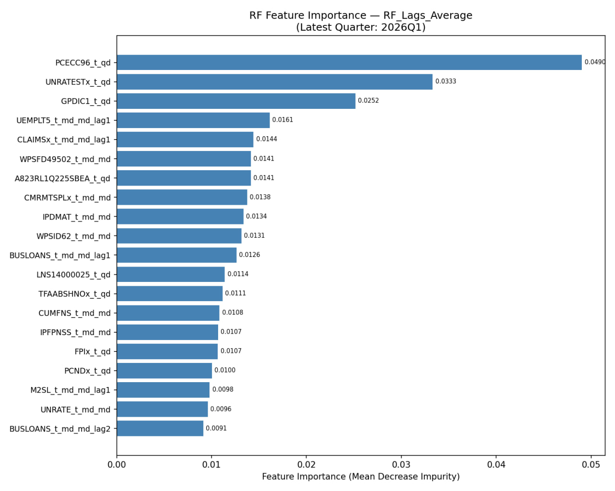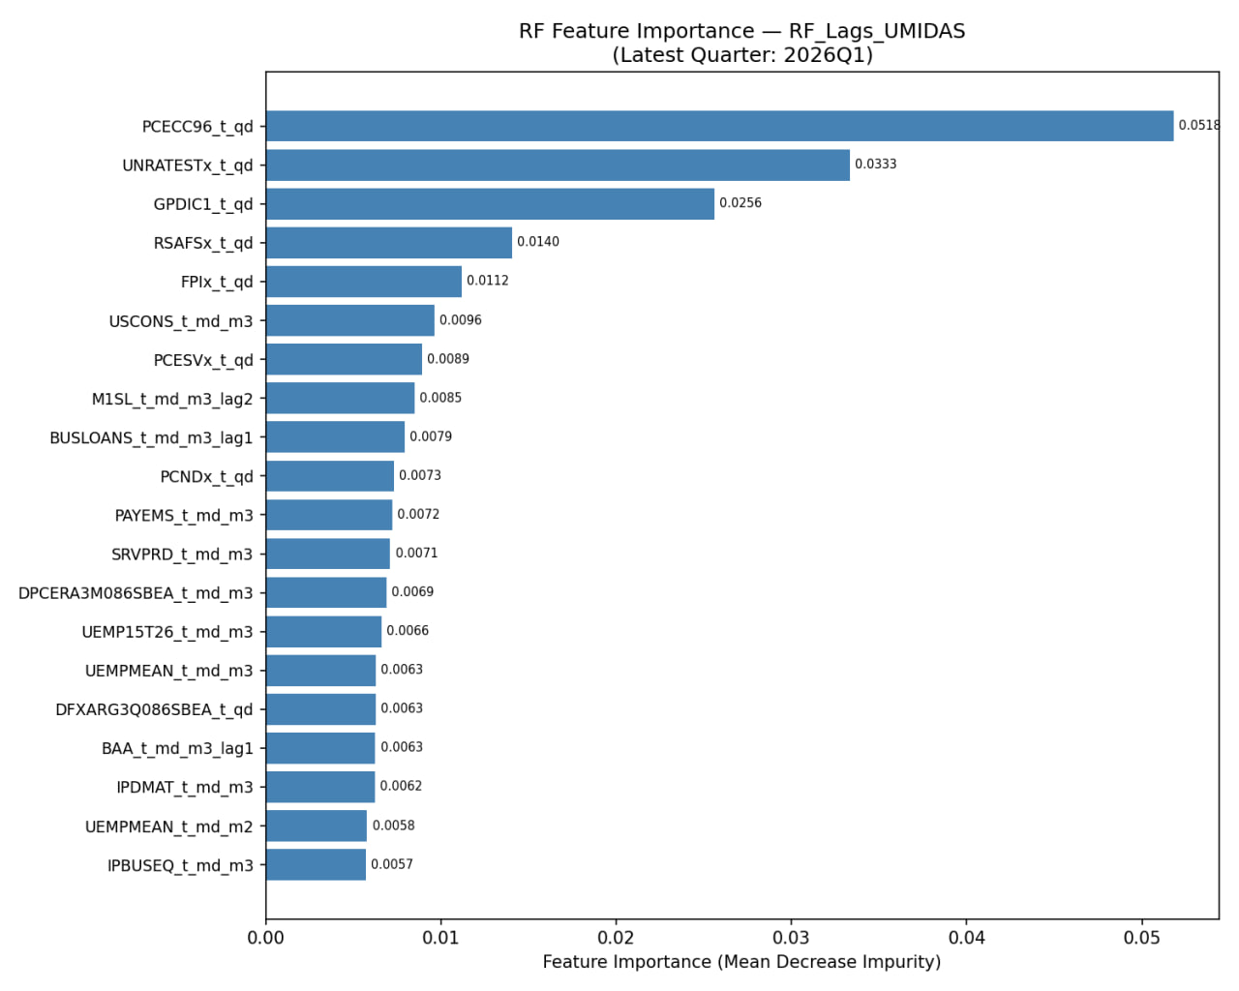

2.3.4.3 TABLES E: LASSO Coefficients for 2026 Q1

LASSO Average
Variable Code | Coefficient | Description/Type
PCECC96_t_qd | +182.1586 | Real Personal Consumption Expenditures
SRVPRD_t_md_md | +144.7477 | Service-Providing Industries
M2SL_t_md_md | -70.6254 | M2 Money Stock
GCEC1_t_qd | +56.8027 | Real Govt Consumption & Investment
ULCNFB_t_qd | -43.4757 | Unit Labor Cost (Nonfarm Business)
GPDIC1_t_qd | +36.5838 | Real Gross Private Domestic Investment
EXPGSC1_t_qd | +24.4420 | Real Exports of Goods and Services
SLCEx_t_qd | +14.5272 | State and Local Consumption
IPB51220SQ_t_qd | -8.9947 | Industrial Production (Consumer Goods)
PCNDx_t_qd | +8.0736 | Personal Consumption (Non-durable)
TNWMVBSNNCBx | +2.6475 | Household Net Worth
covid_recover_qd | +2.4336 | Recovery Indicator
covid_crash_qd | -1.5980 | Shock Indicator
CP3Mx_t_md_md | +0.6742 | 3-Month Commercial Paper Rate
BOGMBASEREALx | +0.3052 | Real Monetary Base
CLAIMSx_t_md_md | -0.1679 | Initial Unemployment Claims

LASSO Average + Lags
Variable Code | Coefficient | Notes
PCECC96_t_qd | +191.8579 | High impact consumer spending
SRVPRD_t_md_md | +173.2279 | Service sector dominance
GCEC1_t_qd | +62.5726 | Government expenditure
ULCNFB_t_qd | -46.0166 | Labor cost pressure
GPDIC1_t_qd | +36.7052 | Investment growth
EXPGSC1_t_qd | +24.1505 | Export performance
IPB51220SQ_t_qd | -9.2825 | Industrial production drag
PCNDx_t_qd | +4.0939 | Non-durable goods
TNWMVBSNNCBx | +2.9471 | Net worth factor
covid_recover_qd | +1.0655 | Recovery trend
covid_crash_qd_lag1 | +1.0655 | Lagged shock response
covid_crash_qd | -0.7659 | Immediate shock effect
CP3Mx_t_md_md | +0.7484 | Interest rate component
UNRATE_t_md_md | +0.5290 | Unemployment rate
BOGMBASEREALx | -0.1165 | Real monetary base (negative shift)

LASSO + UMIDAS

Variable Code | Coefficient | Observation
PCECC96_t_qd | +161.9201 | Consistent primary driver
GCEC1_t_qd | +65.0002 | Strong government influence
PCESVx_t_qd | +57.2080 | Services consumption
ULCNFB_t_qd | -44.8315 | Negative labor cost correlation
GPDIC1_t_qd | +38.5864 | Domestic investment
SRVPRD_t_md_m1 | -30.0095 | Service production (month 1)
EXPGSC1_t_qd | +24.6115 | Real exports
PCNDx_t_qd | +13.2768 | Non-durable spending
IPB51220SQ_t_qd | -10.4238 | Industrial production contraction
USSERV_t_qd | +10.0442 | Total US Services
TNWMVBSNNCBx | +3.7883 | Household wealth
UEMPLT5_t_md_m1 | -1.9652 | Unemployment duration (<5 weeks)
covid_recover_qd | +0.2148 | Minimal recovery impact

2.5 Table F: Supabase Table

Supabase Table | Upserted by | Used by
gdp | fred_loader.sync_csv_to_supabase() (upsert, conflict on sasdate) | fred_loader.fill_missing_gdp_quarters() (select latest sasdate)
 | fred_loader.fill_missing_gdp_quarters() (upsert missing quarters) | output_x._load_gdp() (select all rows via read_table)
 |  | output_x._load_gdp_with_flash() (select all rows)
 |  | prediction.prediction_pipeline() (select all rows )
 |  | historical.push_evaluation_to_supabase() (select all rows)
 |  | evaluation_table_hist.push_forecasts_to_evaluation() (select all rows)
 |  | fetch_functions.fetch_historical_data() (select between dates)
 |  | actual_fetch_functions.fetch_historical_data() (select between dates)
fred_md | fred_loader.sync_csv_to_supabase() (upsert fred_md.csv, conflict on sasdate) | ragged_edge.fill_ragged_edge() (select all rows via read_table, called from test.run())
fred_qd_x | fred_loader.sync_csv_to_supabase() (upsert fred_qd_X.csv, conflict on sasdate) | ragged_edge.fill_ragged_edge() (select all rows via read_table, called from test.run())
filled_md | ragged_edge.upsert_table() (upsert filled data, conflict on sasdate, called from test.run()) | output_x.load_filled_data() (select all rows via read_table)
filled_qd | ragged_edge.upsert_table() (upsert filled data, conflict on sasdate, called from test.run()) | output_x.load_filled_data() (select all rows via read_table)
model_forecasts | prediction._push_to_supabase() (upsert, conflict on model_name, quarter_date, month_date) | prediction.fetch_all_model_forecasts() (paginated select *)
 | prediction.compute_and_push_model_average() (upsert All_Model_Average) | prediction.nowcast_single_latest() (select latest nowcast to fill missing GDP)
 | historical.push_poos_to_supabase() (upsert POOS records) | output_x._load_gdp_with_flash() (select Ensemble nowcast for unreleased quarters)
 | ci_update.update_ci_columns() (row-by-row update CI columns via .eq("id", ...)) | poos.cut_and_fill() (select nowcasts to fill GDP gap)
 |  | ci_update.fetch_all_model_forecasts() (paginated select *)
 |  | evaluation_table_hist.fetch_all_model_forecasts() (paginated select *)
 |  | evaluation_table_hist.push_forecasts_to_evaluation() (select filtered by run_date)
 |  | fetch_functions.fetch_nowcast_data() (select by quarter_date)
 |  | fetch_functions.fetch_nowcast_x_labels() (select by quarter_date)
 |  | fetch_functions.fetch_confidence_intervals() (select CI columns by model/quarter)
 |  | fetch_functions.fetch_historical_data() (select predictions between dates)
 |  | actual_fetch_functions.* (same 4 functions as above)
evaluation | historical.push_evaluation_to_supabase() (upsert, conflict on quarter_date, version) | evaluation_table_hist.calculate_and_upsert_rmse() (select all rows)
 | evaluation_table_hist.push_forecasts_to_evaluation() (upsert, conflict on quarter_date, version) | dm_test.fetch_forecast_data() (select quarter_date, version, gdp_actual, all model columns)
rmse | evaluation_table_hist.calculate_and_upsert_rmse() (upsert per model+version, conflict on model, version) | prediction.nowcast_single() (select RMSE by model, version for CI calculation)
 | evaluation_table_hist.calculate_mean_rmse_by_model() (upsert mean RMSE as version=0) | prediction.nowcast_single_latest() (select RMSE by model, version)
 |  | ci_update.update_ci_columns() (select all rows to recompute CIs)
 |  | fetch_functions.fetch_rmse() (select by model + version)

Requirements
3. technical documentation - total 15 pgs, single spaced 11pt

PART I: WHOLE GROUP
- Project overview: restate the problem you are addressing and the main goal of the project; short description of the app and its intended users; include an overview of the tools used throughout the project.
- Overall design: overall architecture of your web application, focusing on how the front-end and back-end components interact; high-level overview of the data flow between user inputs, data processing, modeling, and output display.
- Data and methodology: List the data sets used in your project and briefly describe how they were obtained; summarize any pre-processing steps taken to prepare the data for analysis and describe key transformations or feature engineering steps; short summary of the modeling or analytical techniques used in your project.

PART 2: BACK END
- describe final data sources, any data cleaning, transformation, or pre-processing steps
- modeling and analysis process:
a) justify choice of models or algorithms and describe how they were trained, validated, and evaluated
b) Include relevant performance metrics, information about cross-validation, and any hyperparameter tuning that was performed
c) explain how the processed data or model outputs were made accessible to the front-end.
- discuss any challenges you encountered during back-end development
- Highlight trade-offs related to data quality, model performance, or deployment, and any suggested areas for improvement or potential future work.
- summarize the roles and contributions of each team member
- Reflect on your timeline, milestones, and any deviations from the original proposal.

PART 3: FRONT END
- describe the overall structure and layout of the application, including how users interact with the interface (key UI components & their functions; how they communicate w backend e.g. how input is captured & passed to BE for processing, how results are retrieved & displayed)
- explain rationale behind design decisions, justify choices related to layout, styling, and interaction design
- include summary of user testing if applicable
- discuss any know limitation of the current UI and suggest possible improvements or additional features that could enhance usability in future work
- summarize the roles and contributions of each team member
- Reflect on your timeline, milestones, and any deviations from the original proposal.

https://www.bls.gov/opub/hom/opt/data.htm#edn1

